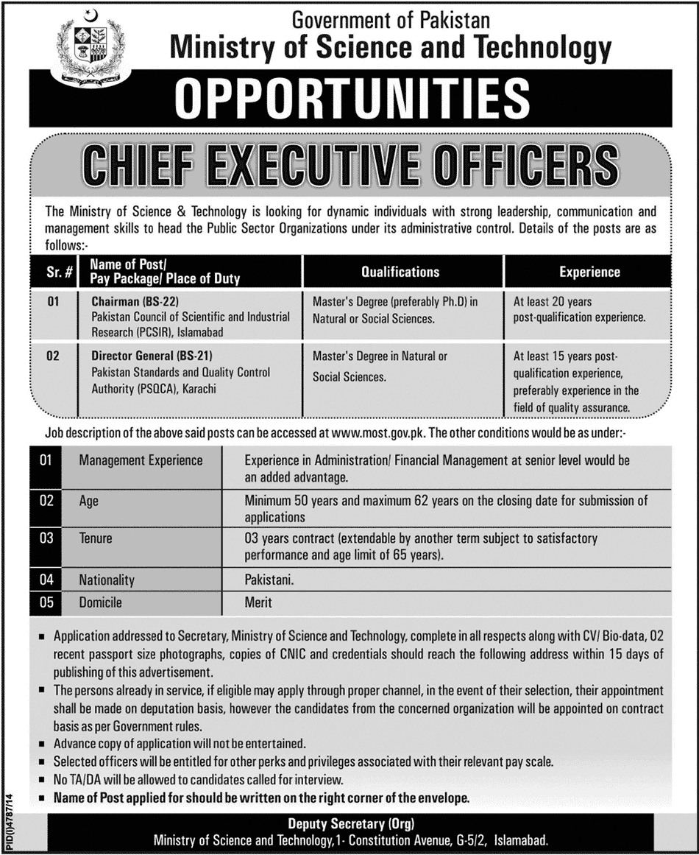

**Job description of Director General, PSQCA**

* The Director General serves as chief executive of the Authority.
* Head of National Standards Body (NSB) of Pakistan.
* Final approval for Conformity Assessment (CA) activities.
* Keeps the Board and Chairman fully informed about regular working of the Authority and on all the important happenings in the Authority.
* Informs the Board and Ministry about trends, issues, and activities in order to facilitate policy-making. Recommends policy positions.
* He heads financial control and follows financial discipline includes inspection and testing of products and services for their quality, specifications and characteristics, during use and for import and export purposes.
* Assures program quality and organizational stability through development and implementation of standards.
* Coordination and cooperation with local, regional and international organizations, associations, societies being head of the Authority.
* All legal matters pertaining to PSQCA is supervised by Director General.
* The PSQCA has to communicate with public and Governmental agencies on national and international levels, on matters connected with standardization, conformity assessment and other activities of the Authority through Bulletin, circulars, books, public media or through seminars, symposia, workshops etc.